NBA Season (2022/2023): A Deep Dive

Data Science Final Paper

Abstract

There was a great deal of individual brilliance displayed throughout the NBA season of 2022/2023, showcasing the unparalleled skills and achievements of players across the league. From seasoned veterans to emerging talents, this season was filled with notable performances that will last until next season. Analyzing this dynamic season was made possible through the comprehensive NBA stats and salaries dataset from Kaggle, an online community platform for data scientists and machine learning enthusiasts. An understanding of the roles and contributions of players was provided by this dataset. The dataset allowed us to search into the complexity of each player's performance, shedding light on their scoring efficiency, defensive skills, and playmaking abilities. The dataset not only evaluated traditional skills but also facilitated a deeper exploration of advanced statistics, enabling a more comprehensive assessment of player value. Overall, the 2022/2023 NBA season showcased unparalleled individual talents, with the dataset serving as an insight to recognize the various roles of players in shaping each game and the season.

Introduction

Beginning a data-driven analysis of the 2022-2023 NBA season, our look is directed toward a dataset sourced from the Kaggle platform. This dataset is a source of information, revealing relationships between player statistics and financial aspects in the league.

As we look into this dataset, we’re paying attention to the important stats which are the key values that help us uncover insights, patterns, and interesting details about the NBA’s 2022-2023 season. These insights can be used to make better decisions, improve team performance, and shape winning strategies. The data can be used to track player performance and anticipate future outcomes.

Problem Statement & Hypothesis

As we navigate the information, our main question arises: among the diverse player positions, which showcased the most exceptional performance during this season? This question acts as our guide, leading us to explore the roles of point guards, shooting guards, small forwards, power forwards, and centers. Each position has a specific role and depending on that role, the stats will vary. The NBA centers also known as “the bigs” are becoming more nimble and agile while being gifted with their size/height. For example, Victor Wembanyama made his NBA debut for the Spurs in the 2023/2024 season, and his ability to put the ball on the floor, shoot step-back jumpers out of the post, step-back threes, catch-and-shoot threes, and block shots as a center and power forward is special. Since bigs are becoming increasingly more skilled in all areas of the court we expect the centers or small forwards to have the most exceptional performance during this season.

Data

Let’s take a closer look at where our data comes from and how we prepared it for our analysis. We got our information from a reliable resource known as Kaggle, which is a hub that contains various datasets. This particular dataset we picked contains information on NBA players’ stats and salaries for the 2022-2023 season.

In our dataset, each row represents an individual NBA player, and the columns contain different types of information, such as numbers for player achievements, text for details, and financial figures. To make sure we’re focusing on what matters for our analysis, we cleaned up the dataset by narrowing it down to the important stats. The dataset had already undergone a cleaning process, ensuring there were no missing values or any factors that could potentially hinder our analysis. This left us with 467 rows and 33 columns, leaving us with a clear view of player performances.

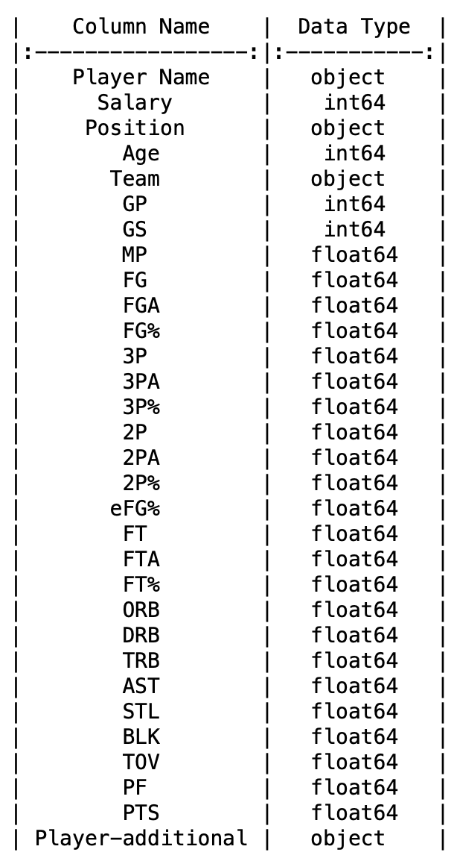

Variables

Within our dataset, a diverse array of variables captures the center of player performances. These variables range from player-specific information to detailed statistical metrics which helped aid us in our analysis. Player details include “Player Name”, “Position”, “Age”, “Team,” and “Salary”, providing necessary information for our analysis. From a statistical standpoint, numerical indicators such as “Points (PTS)”, “Assist (AST)”, “Rebounds (TRB)”, and defensive metrics like “Steals(STL)” and “Blocks(BLK)” evaluate player contributions on the court. Shooting efficiency is set out through metrics such as “Field Goal Percentage (FG%)” and “Free Throw Percentage (FT%)”, while the variables “Games Player (GP)” and “Games Started (GS)” offer insights into a player’s overall participation and starting status within their team. Including these metrics helps us thoroughly explore and understand the many aspects of how players performed during the specified NBA season.

Analysis

To help figure out how players performed, we used the statistical library as a tool. With this, we checked important values such as averages, ranges, and how much the numbers changed. These numbers helped us get a good idea of how well players did in different areas such as scoring and defense. Additionally, we used Matplotlib to create simple and clear bar charts showcasing the leading players in their respective positions. We opted for Matplotlib because it’s straightforward and effectively conveys information to the reader, making it easier to grasp the performance comparisons among players in the 2022-2023 NBA season. The last visual we used was screenshots of print statements that are in between the graphs showing the lead player's team stats and accomplishments.

From here, we categorized each player's position, defining specific metrics to assess their performance. For instance:

* Point Guards (PG): Ball Handling (AST), Scoring (FG, 3P, 2P, FT, PTS), Perimeter Defense (STL), and Decision-Making (TOV).
* Shooting Guards (SG): Scoring (FG, 3P, 2P, FT, PTS), Perimeter Defense (STL), and Playmaking (AST).
* Small Forwards (SF): Scoring (FG, 3P, 2P, FT, PTS), Perimeter Defense (STL), Rebounding (ORB, DRB, TRB), and Defense (BLK).
* Power Forwards (PF): Scoring (FG, 2P, FT, PTS), Rebounding (ORB, DRB, TRB), Defense (BLK), and Interior Scoring (2P%).
* Centers (C): Scoring (FG, 2P, FT, PTS), Rebounding (ORB, DRB, TRB), Defense (BLK), and Interior Scoring (2P%).

This organized approach ensured a thorough evaluation of player performances across diverse skill sets. For each position, we carefully picked each measure to highlight important parts of a player’s impact on the game. We determined the top player for each position by identifying the player leading in the most categories. The player who excelled in the majority of categories was considered the best in that position by emphasizing consistency across multiple aspects of the game. We then take a look at these players by their teams and see how they favor them as well to get an optimal look at these individual players and see just who had the best performance among the 5 positions.

Results

Point Guards (PG):

In the realm of ball handling and scoring, Shai Gilgeous-Alexander emerged as a standout performer among Point Guards. His exceptional skills were particularly evident in key scoring fields such as field goals (FG), 2-point field goals (2P), and free throws (FT). This dominance underscores Shai Gilgeous-Alexander’s proficiency in both perimeter and interior scoring, contributing significantly to his team’s offense.

The bar charts below demonstrate Shai Gilgeous-Alexander’s leading position in these categories, providing a clear representation of his scoring ability. The distinctive orange bars highlight his dominance above the blue bars that represent the performance of every other Point Guard.

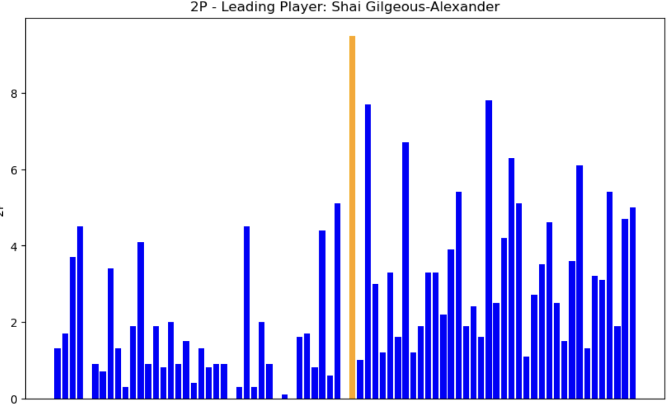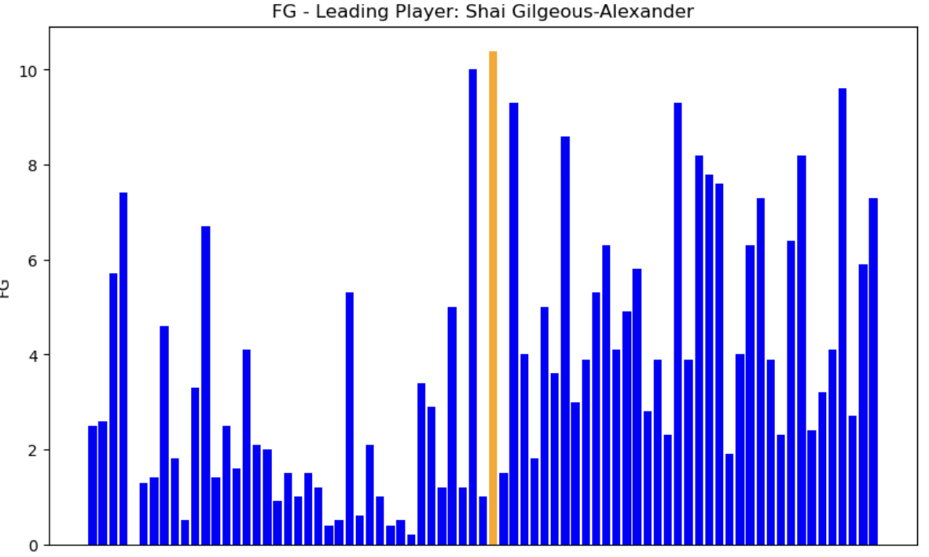

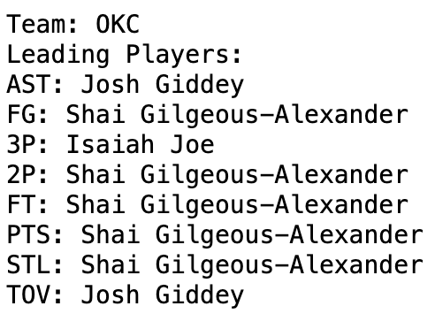

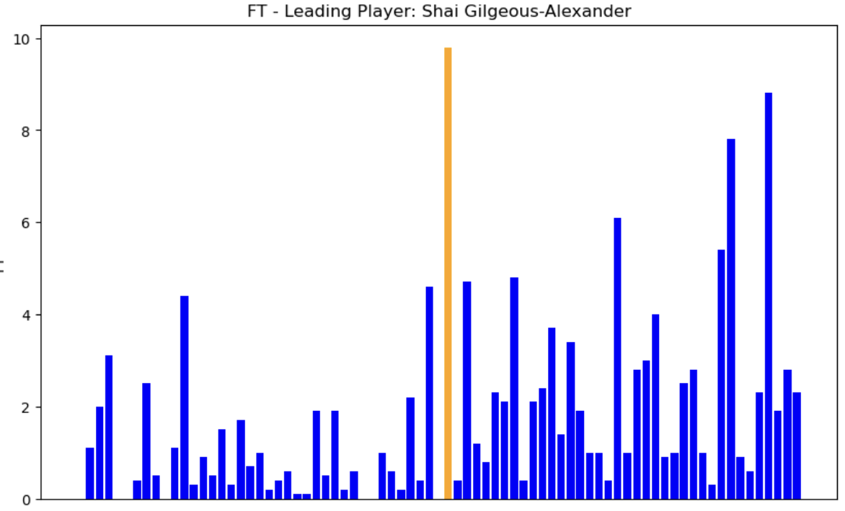

Shooting Guards(SG):

Donovan Mitchell emerged as the leading performer showcasing remarkable skills across critical scoring categories. Mitchell’s standout performance was demonstrated in his field goals (FG), three-pointers (3P), and total points scored (PTS). These key performance indicators paint a clear picture of Mitchell’s scoring proficiency and overall impact as a premier shooting guard.

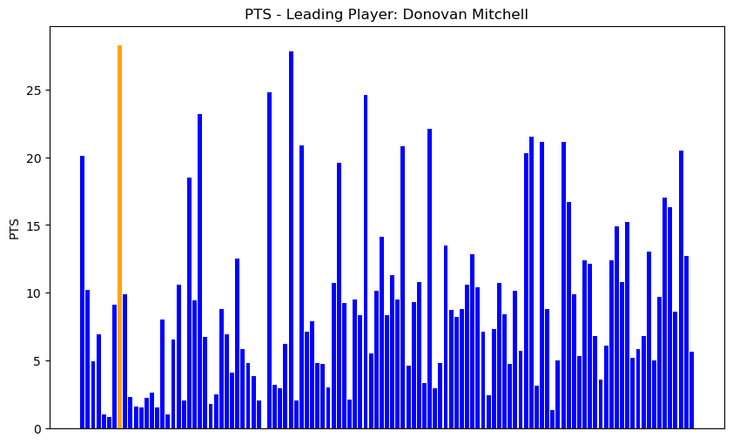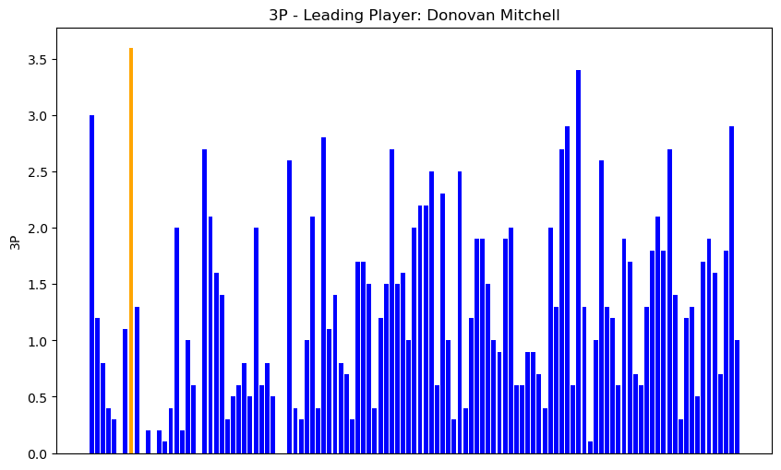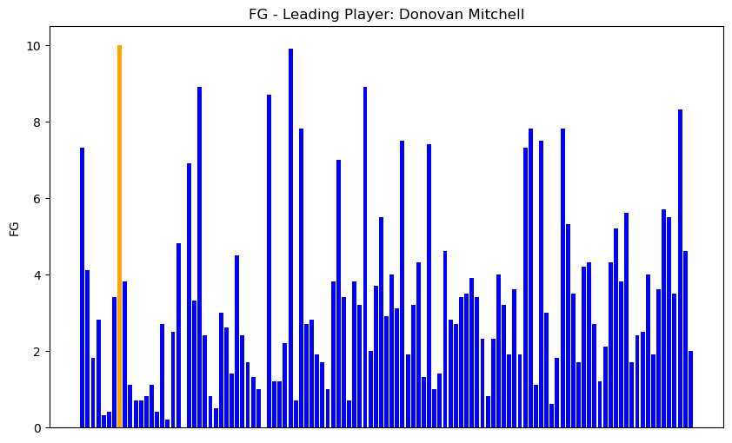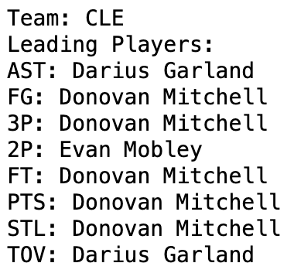

Small Forwards(SF):

Jayson Tatum had the all-around best performance among the small forwards. A true small forward since he takes the top spot when it comes to free throws (FT), points (PT), defensive rebounds per game (DRB), and total rebounds per game (TRB). His performance makes a big impact on his team's success.

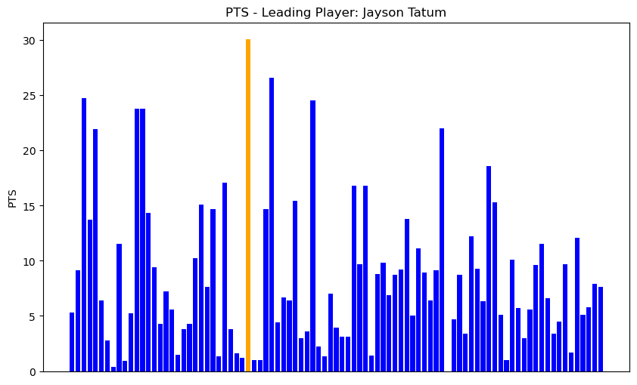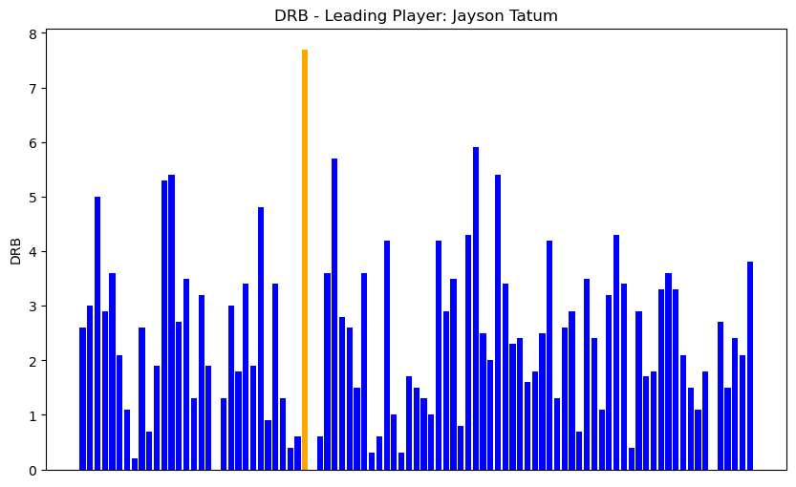

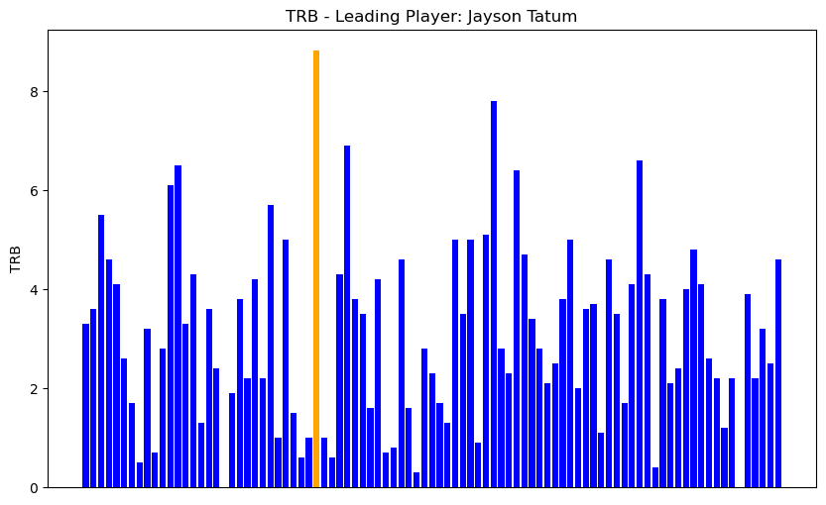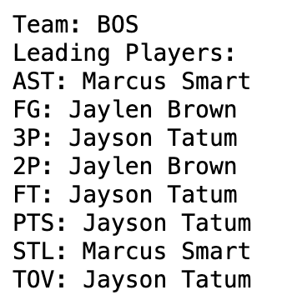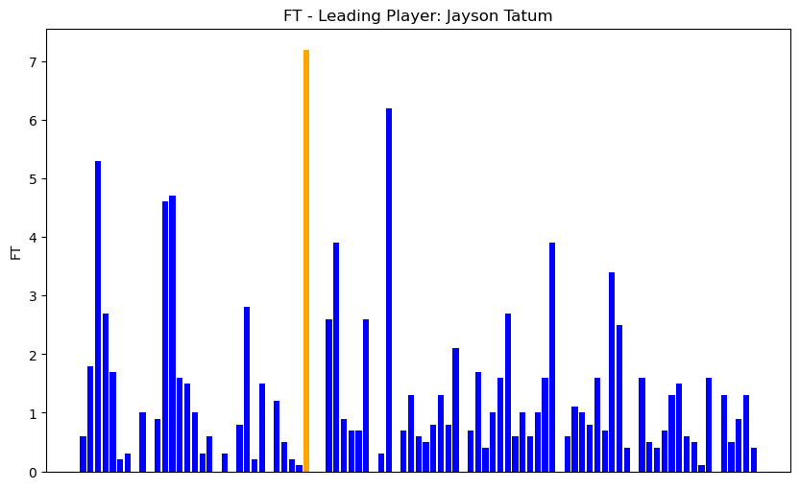

Power Forwards(PF):

Giannis Antetokounmpo is an explosive athlete who can jump out of the gym and run the floor like a guard but he is a power forward that is built for rebounding. He led the power forwards in field goals (FG), free throws (FT), two-point field goals (2P), points (PTS), defensive rebounds per game (DRB), and total rebounds per game (TRB). He is a skilled scorer who can shoot from the perimeter and finish at the rim. Giannis Antetokounmpo also known as “Greek Freak” led the Milwaukee Bucks of the NBA to a championship just recently in 2021.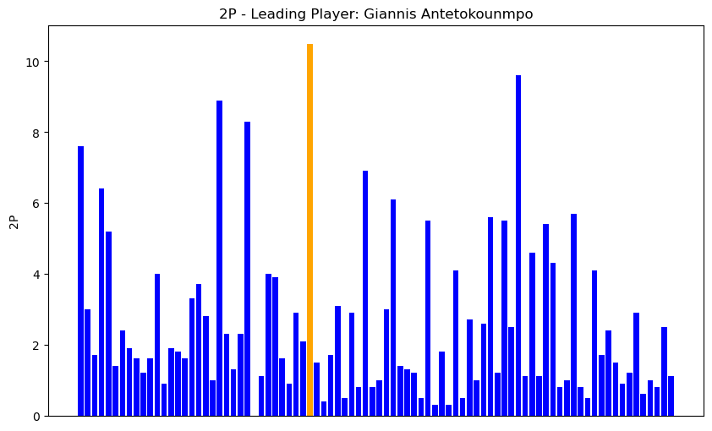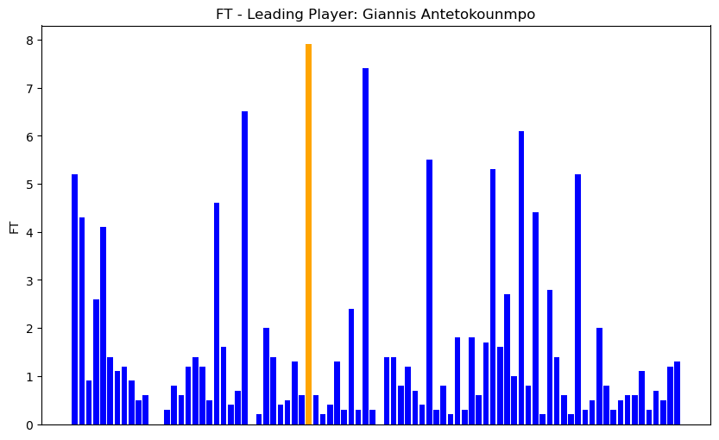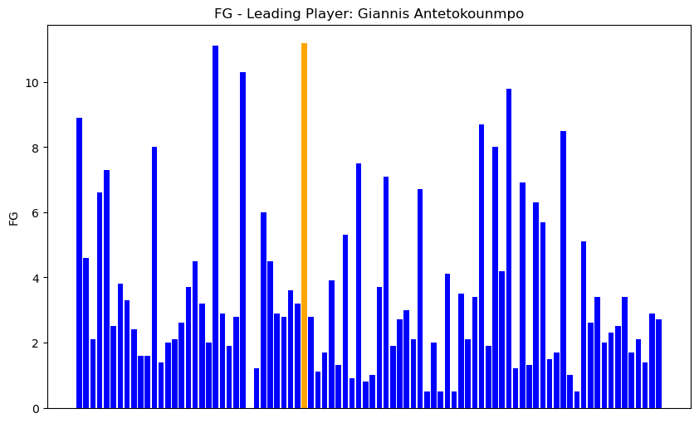

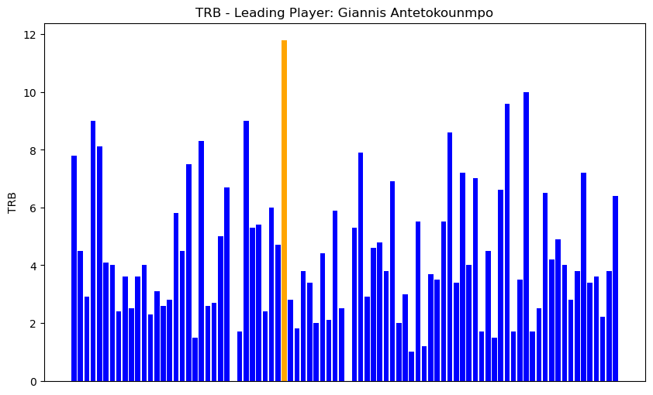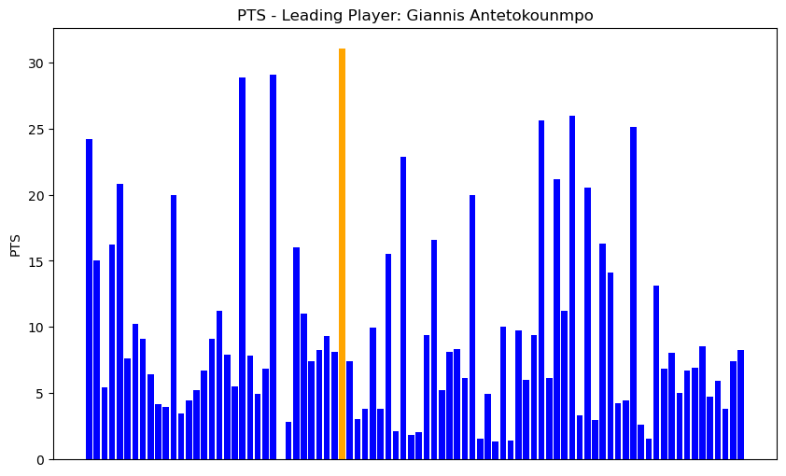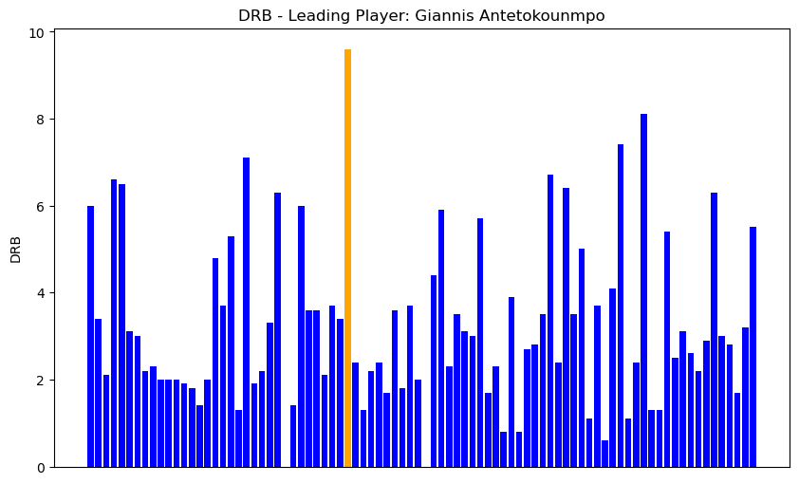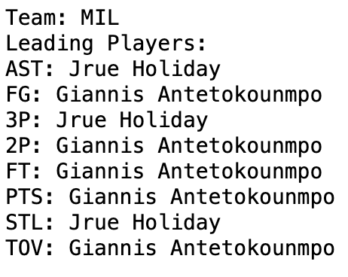

Centers(C):

In the analysis of centers, Joel Embiid emerges as the leading center. He demonstrated exceptional skills in the scoring categories. Embiid’s dominance is highlighted by his leading performances in field goals (FG), two-point field goals (2P), free throws (FT), and total points scored (PTS). These key performance indicators showcase Embiid’s scoring versatility, making him a cornerstone in his team’s offensive strategies.

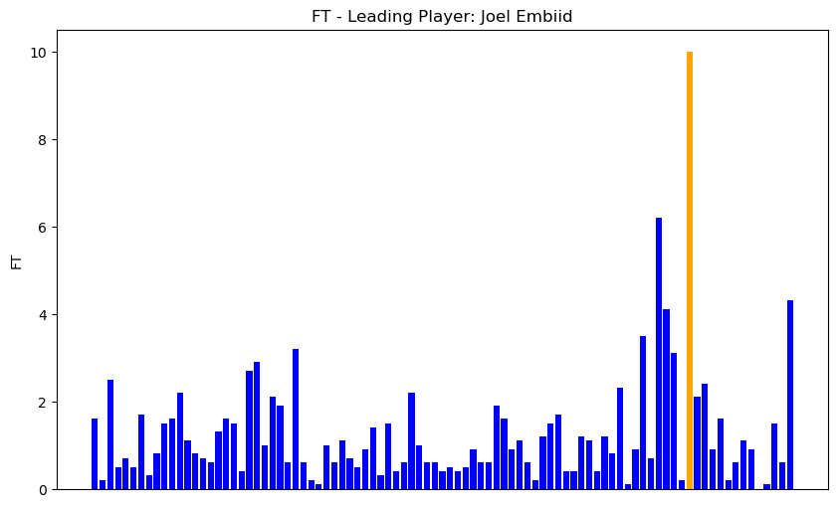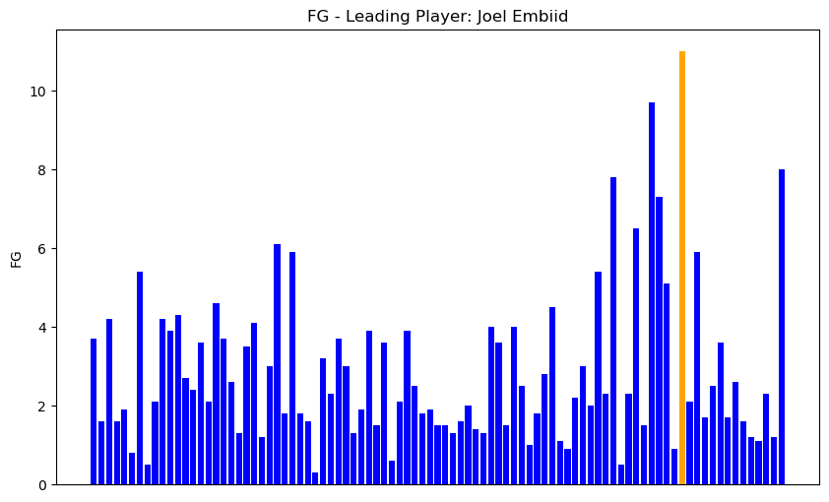

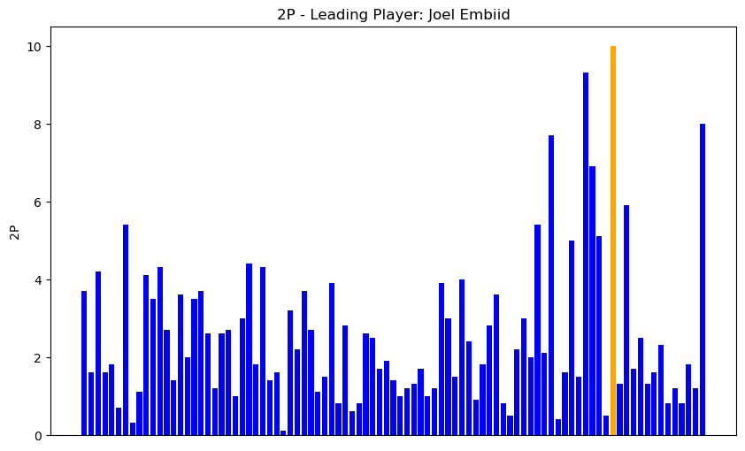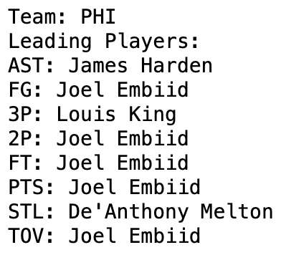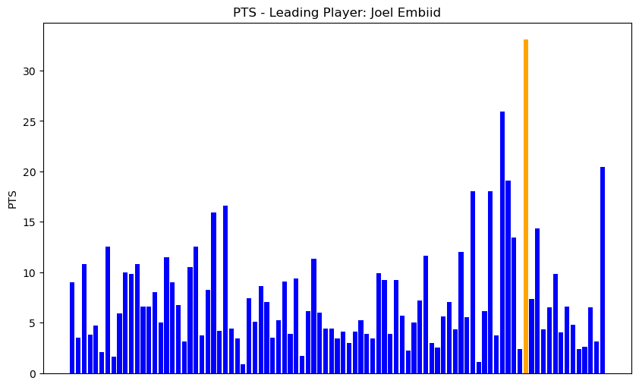

Conclusion

In conclusion, our analysis of the 2022-2023 NBA season successfully identified top-performing players in various positions. Through a careful examination of specific performance categories, we successfully achieved our primary objective by highlighting the standout performers who stood out against others. Matplotlib proved to be an effective tool for creating clear and informative bar charts that highlighted the leading players in various positions. As we delved into the diverse roles of point guards, shooting guards, small forwards, power forwards, and centers, our central question revolved around identifying the position that showcased the most exceptional performance during the season.

Among the analysis of player performances, it became clear that centers, and specifically small forwards, emerged as noteworthy contributors. The evolution of NBA centers, exemplified by the debut of players like Victor Wembanyama, showcased increased versatility and skill across the court. Expectations for exceptional performances were particularly high for centers and small forwards due to their evolving skill sets.

A standout player in our analysis was Giannis Antetokounmpo (Power Forward), known as the "Greek Freak," who consistently outperformed others in his power forward position. Giannis exhibited exceptional all-around statistics, leading in crucial categories such as field goals (FG), free throws (FT), two-point field goals (2P), points (PTS), defensive rebounds per game (DRB), and total rebounds per game (TRB). His explosive athleticism, combined with a unique ability to shoot from the perimeter and finish at the rim, solidified his status as a dominant force in the league. Giannis Antetokounmpo's impact extends beyond individual achievements as a power forward. This is evidenced by our statistical evaluation of his impact on his team, based on his stats as a Milwaukee Buck and his leadership in guiding the Milwaukee Bucks to an NBA championship in 2021. In the complex landscape of player performances, Giannis stands as a well-favored and multifaceted player, showcasing skills that extend beyond statistical metrics.

What would we add if we had more time:

* Analysis of variance (ANOVA), which is a statistical technique used to check if the means of two or more groups are significantly different from each other. ANOVA checks the impact of one or more factors by comparing the means of different samples. By using this statistical technique we would have been able to get a deeper understanding of our variables (i.e. AST, FG, 3P, 2P, FT, PTS, STL, TOV, ORB, DRB, TRB, and BLK) based on player's stats for each position as a whole and discern whether or not they are statistically different.
* We also had NBA Veteran (seasons played >= 6 || age >= 30) data that would have let us get an understanding of why all the top players in their positions are NBA veterans. We would have looked at the number of games started (GS) and the number of games played (GP)